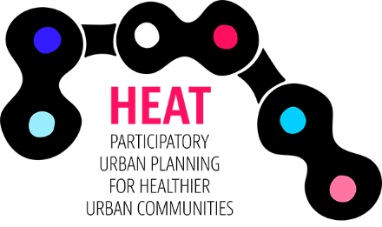

HEAT TOOL TRAINING AND CALCULATIONS IN PROJECT CITIES AND REGIONS

Place / Address (Remove if not needed)

1 Preface

2. Jurmala

2.1. Description of the city

2.2. Choosen values

2.3. Results of the calculations

2.4. Usage of results and future needs

2.5. Local seminar on HEAT calculations

3. Tartu

3.1. Description of the city

3.2. Choosen values

3.3. Results of the calculations

3.4. Usage of the results and future needs

3.5. Local seminar on HEAT calculations

4. Turku region

4.1. Description of the area

4.2. Choosen values

4.3. Results of the calculations

4.4. Usage of the results and future needs

4.5. Local seminar on HEAT calculations

5. Stockholm region

5.1. Description of the area

5.2. Choosen values

5.3. Results of the calculations

5.4. Usage of the results and future needs

5.5. Local seminar on HEAT calculations

6. Summary

