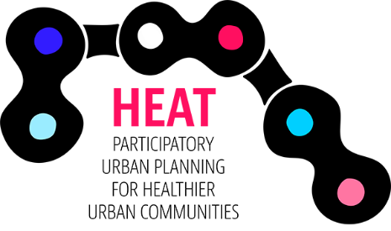

Jurmala study visit & seminar
16 – 17 May 2019

AGENDA

Saturday, 16 May
Project meeting day and workshop with local planners, Jurmala Central Library, Strēlnieku prospekts 30, Jurmala, LV 2015.

9:30 – 10:00 Welcome and Introductions
10:00 – 12:00 Results of HEAT calculation (Cities presentations)
12:00 – 13:00 Lunch
13:00 – 14:30 Continue with results of HEAT calculation
14:30 – 15:30 Campaigns/ Emilia
15:30 – 16:00 Coffee break

16:00 – 18:00 Workshop with local planners and stakeholders

19:00 – 21:30 Dinner

Friday, 16 May
Project meeting day, Jurmala Central Library, Strēlnieku prospekts 30, Jurmala, LV 2015.

10:00 – 12:00 Administrative questions and next steps in project implementation / Laura
12:00 – 13:00 Lunch
13:00 – 16:00 Biking around the Jurmala

