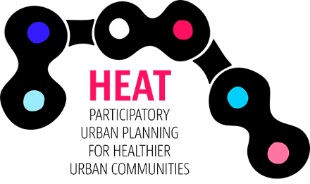

CAMPAIGN CHECKLIST

- Write the names of your potential campaigns in the
How well does your campaign fulfill each criteria?

0 = not at all 1= low

2 = moderate 3= high
numbered boxes at the top of each column.
- Score each potential campaign based on the assessment
criterion.
3) Add the total number of points for each column.

Potential campaigns>>  Write the names of your campaign ideas | A. | B. | C.
1. Aligns with successful model campaigns
2. Has reasonable prospects for success
3. Results in definite, quantifiable improvement in the community
4. Sets long-term improvements in citizen participation in urban planning and/or biking environment
5. Engages “key players”
6. Fits your organization’s mission, culture and resources
7. Involves current members/stakeholders/citizens in a meaningful way
8. Attracts new members/stakeholders/citizens
9. Inspires passion among at least a portion of your constituency
10. Builds your organization’s political power/influence
11. Leverages positive media and promotion of your organization
12. Has strong income potential (if relevant)
Total score:
(Max: 36 points)

The total number isn’t everything, some criteria may be more relevant/important to your organization than others. But large differences in totals is a good indicator of a campaigns chances of success.

Adapted from the Alliance for Biking & Walking Campaign Planning Workbook

