Kick-off Meeting – Practical Information

Welcome to Turku! The HEAT Project kick-off will take place on 16-18 May in Turku, Finland. Below you can find the most important information to help make your arrival to and stay in the city smooth and easy.

Meeting Venue
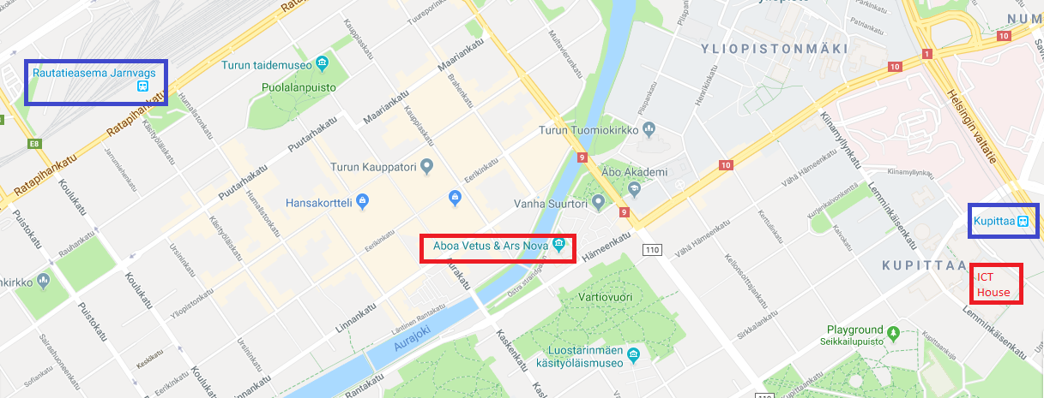

May 16 – Aboa Vetus Museum, Billiard Room, Itäinen Rantakatu 4–6
May 17 & 18– ICT House, Joukahaisenkatu 3-5

How to get to Turku centre from Turku Airport:
From the airport you can easily reach the city center by taking a bus. Bus number 1 departs from the airport to the Market Place 3 times per hour and costs 3 EUR/single fare (route Lentoasema / Flygstationen – Kauppatori / Salutorget). You can plan your journey here. You can buy the ticket from bus driver. Note that they only accept cash. Taxi fares are approximately 25 EUR from the airport to the city center. They normally wait outside the terminal but in case they don’t, their phone number is: +358 2 10041.

How to get to Turku from Helsinki-Vantaa Airport:
The easiest way to arrive from Helsinki-Vantaa Airport to Turku is by train. Trains leave almost every hour and cost between 10-20 euros depending on how far in advance tickets are purchased. Tickets can be purchased online at www.vr.fi. You can either take the train to the Main Railway station (Rautatieasema) or the station before, Kupitaa. The two train stations are highlighted in blue in the map above.

ACCOMMODATION
Many hotels in Turku City center are within walking distance from the meeting spaces. Below are a few recommendations to check out that are near the meeting venues.

- Scandic Plaza Turku - Yliopistonkatu 29, www.scandichotels.fi
- Original Sokos Hotel Seurahuone - Eerikinkatu 23, www.sokoshotels.fi
- HVC Hostel Turku, Turku - 20 Hämeenkatu, https://www.hvcasunnot.fi/hvc-hostelli-turku/

MEALS
All lunches will be provided as well as dinner on the 16th as in the agenda. Please notify the organizers about any special diets while registering for the meeting at https://goo.gl/forms/eJhfjdfK6gvThVOQ2

CONTACT PERSON IN TURKU
In case you need help, please contact Hanna Dunning +358 40 1788 926 or Karolina Mackiewicz +358 40 507 5069.

