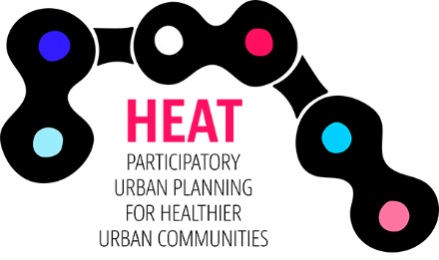
STEERING GROUP MEETING
Project “HEAT – Participatory urban planning for healthier urban communities”

MEMO
Monday 11 June 2018, 14:00-15:00 Finnish / 10:00-11:00 Swedish time
Online

PARTICIPANTS
Karolina Mackiewicz, Baltic Region Healthy Cities Association
Hanna Dunning, Baltic Region Healthy Cities Association
Mari Sinn, Council of Southwest Finland
Kristiina Meltovaara, Turku University of Applied Sciences
Merit Tatar, Institute of Baltic Studies
Elizabete Krivcova, Jurmala City Council
Mati Raamat, Tartu City Government
Hans Stoops, Cykelfrämjandet
Leena Telkkinen, Central Baltic Programme

CC: project team members

MEMO
- Approval of agenda
Agenda was approved. Part of the agenda was skipped due to the fact that the SG members, who participated in the meeting were also present at the kick-off meeting and know the project very well.
- Introduction of the SG members and their experience with the participatory urban planning and development of biking infrastructure
The three out of four participating SG members know each other from the kick-off meeting. Elizabete Krivcova joined the meeting later and introduced herself to the group. Elizabete is a member of the City Council in Jurmala and responsible for biking. There is currently a political commitment in Jurmala to develop biking infrastructure.
- What is HEAT project about
This part was skipped and the presentation will be sent to all SG members to inform them about the project, expected results and promised outputs. As the SG should steer the project towards reaching the results, its important for the SG members to know what they are.
- Update on the activities and plans so far
After the kick-off meeting, the Lead Partner worked on the communication. The website is now being tendered with the goal to be operational before the study visit to Stockholm on 16-18.9. The final version will be published at the end of September. The SG discussed the address of the website. It was decided that the www.heatproject.eu seems to be the most logical but also the other keywords, like ‘baltic’, ‘central baltic’, ‘urban planning’ etc. should be taken into account for positioning of the website. The LP will talk about it with the web designer.
- Potential challenges in the project, best ways to communicate about the project
The SG members said that at this moment it’s generally too early to think about the challenges, we need to have more activities to see what those challenges can be. The partners represent different organizations and perhaps the challenges won’t be the same. However, some challenges might be to reach out to the target group, i.e. get the people to the workshop and to find a tool/app that will fit the project and all partners.
One practical issue are the bugs in the HEAT tool – during the training Hans found out some and wanted to communicate about them to the HEAT tool administrators but this was not possible due to the website error. LP will communicate about it to the HEAT core group.
The SG members are encouraged to think which channels and networks can be used for communication of the project.
- Next steering group meeting
The next meeting will be organized during the period 2 of the project, unless there are any problems or/and conflicts in the consortium that would require the discussion/decision of the SG.
- Any other issues
The study visit to Stockholm is on 17-18.9 but the partners are encouraged to arrive already on Sunday, 16th to participate in the biking event and parade. It was discussed that this can be an excellent way to start the study visit as this relates to the advocacy and participation. So the study visit will be 16 (for those who can arrive on Sunday) till 18.9. Sunday will be biking event, Monday seminar and Tuesday project team meeting.

