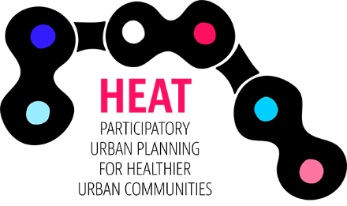

INTERACTIVE WORKSHOPS AND DIGITAL TOOLS

Place / Address (Remove if not needed)

1 Preface

2. Jurmala

2.1. Interactive workshops

2.2. Results and outcome

3. Tartu

3.1. Interactive workshops

3.2. Results and outcome

4. Turku region

4.1. Interactive workshops

4.2. Results and outcome

5. Stockholm region

5.1. Interactive workshops

5.2. Results and outcome

6. Digital tools

7. Summary

